Appendix 1

Research into Council Tax Reduction

Turn2us Benefits Survey
Turn2us are a national charity who help people in financial hardship access welfare benefits, grants and support services. They conduct an annual, national benefits survey to understand the impact of changes in benefits. Their survey conducted earlier this year showed that 83% of low income households have seen no sign of their financial situation improving.

The survey looked at the impact of the following changes: onset of illness or disability, a change in working hours, childbirth and family breakdown. 58% of households experiencing at least one of these events said their outgoings significantly exceed their income. 34% said their debt levels worsened. Even a quarter of those in fulltime work said their debt levels had increased in the last year.

New Policy Institute Research
Data collected by the New Policy Institute shows that although an extra billion pounds was collected in Council Tax in 2013/14, in-year arrears increased by £145m, an increase of over 20% on the previous year. This data has been linked to the changes in Council Tax Reduction Schemes to produce the graph below. The four columns represent the different levels of minimum charges brought in by Local Authorities. It is clear to see that bigger the minimum charge the more likely that an LA will have seen an increase in arrears, and that level of that increase is likely to be much more than for Councils that introduced smaller minimum charges.

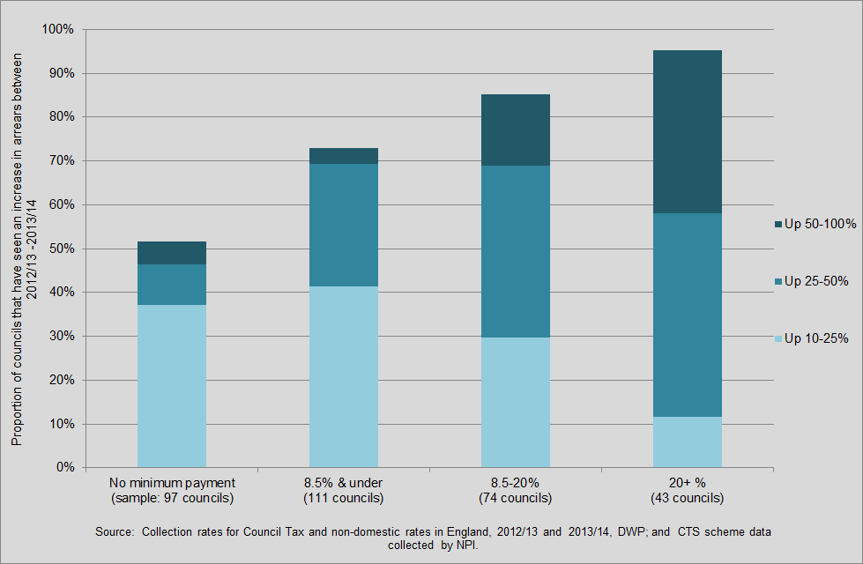

Citizens Advice Bureau
Nationally, the CAB report that Council Tax arrears has overtaken Credit & Store cards, and unsecured personal loans as the number one type of debt that people came to them for help with. This now represents over 20% of CAB’s debt enquiries. Locally, CAB say that enquiries for help with Council Tax arrears have increased, despite the local support scheme retaining the same level of support which was provided by Council Tax Benefit.

